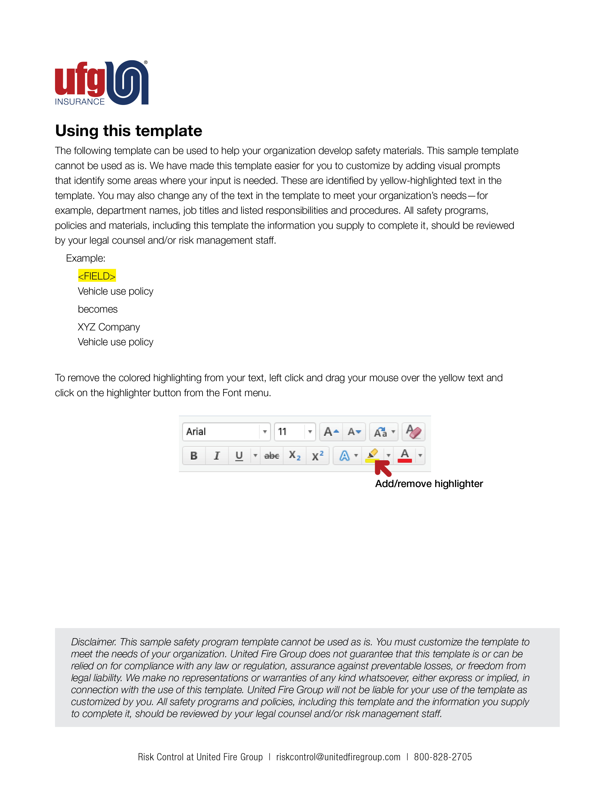

<Company Logo Image Here>

<Company Name>
Vehicle use policy
Date
Introduction
This policy has been developed to communicate what is expected of you in the operation and maintenance of a company provided vehicle. You will be provided with safe, dependable transportation and in return, you are expected to exercise good judgment and demonstrate a thorough understanding of these policies.
Any driver of a company vehicle (or driving on company business in any manner) must meet the following requirements:
- Possess a valid driver’s license.
- Be at least 21 years old.
- Maintain an acceptable driving record according to this policy.
- Follow the guidelines stated in this policy at all times.

Vehicle use
- You have been provided a company vehicle to be used in the performance of your job. Its use is strictly limited to business purposes. It may not be used for personal reasons.
- Only drivers, authorized by your company, are allowed to operate a company vehicle. Loaning the vehicle to friends, neighbors, relatives or anyone else is strictly prohibited.
- From time to time, you may have a need to carry business associates; however, transporting strangers or hitchhikers is a violation of company policy.

Safety
- Seat belts must be used at all times, not only by the driver but by all passengers, as well. Drivers are prohibited from overloading and/or overcrowding a vehicle that may result in unsafe operation. You shall not carry more passengers than the number of occupant safety restraint systems in the vehicle. Drivers are responsible for wearing and enforcing the use of safety restraints by all occupants.
- Driving is a full-time job. Minimize, eliminate or avoid distractions.
- Drive defensively. Anticipate what other drivers are doing. Plan for the unexpected.
- Roads are crowded. Consider all vehicles as potential accidents looking for a place to happen.
- Beware when entering intersections. Wait two or three seconds before entering an intersection from a stoplight or stop sign.
- Signal entry onto freeways and stay in the center or inside lane for ease of emergency maneuvering.
- Do not insist on the right-of-way. Distance yourself from aggressive drivers when in heavy traffic.
- During winter driving, use caution as bridges and overpasses are slippery and freeze before roadways
- Drivers must operate a vehicle only at a speed appropriate to the road, traffic and weather conditions.
- Loose items that could be blown out of pickup trucks or off the flatbed should be secured before driving the vehicle.
- Prior to backing a vehicle with a trailer, a large truck or tractor/trailer, the driver should get out of the cab and assess the area into which the vehicle is to be backed. Look for obstructions, low-hanging electrical wires, tree branches, parked cars, pedestrians or people in the area and any potential for traffic to pass behind while backing. Roll down the window and eliminate any in-cab noise sources (HVAC/radio) so any warning sounds can be heard. If possible, enlist the help of a “spotter.”
- Use turn signals for parking, lane changes and all turns in shopping- and office-center parking lots.
- Always keep a full level of windshield washer solvent.
- Before night driving and when cleaning the windshield, wipe off your headlights.
- If you are wondering whether or not you should turn on your headlights, turn them on.

Mobile phone use and distracted driving
- Mobile phones and hands-free devices are to remain off while the vehicle is moving.
- Allow voicemail to handle your calls and return them when stopped and safe.
- If you need to place or receive a call, pull off the road to a safe location and stop the vehicle before using your phone.
- Ask a passenger to make or take the call.
- Inform regular callers of the best time to reach you based upon your driving schedule.
- Modify voice mail greetings to indicate that you are unavailable to answer calls or return messages while driving.
- Under no circumstances is texting allowed while driving allowed.
- Violation of mobile phone policy will result in disciplinary action and possible termination.

Hands-free options are recognized by the DOT as an acceptable means of using a phone while driving, as long as each of the following restrictions are met:
- Use an earpiece or the speakerphone function.
- Use voice-activated or one-touch dialing. Dialing more than a single button is not allowed.
- The mobile telephone must be located where the driver is able to initiate, answer or terminate a call by touching a single button.
- The driver must be in the seated driving position and restrained by a properly installed and adjusted seatbelt. Drivers are not in compliance if they must unsafely reach for a mobile phone, even if they intend to use the hands-free function.

If a mobile phone application is used on company-provided cell phones, it will be cause for termination or loss of driving privilege if the app is disabled or if the data proves a consistent and continued disregard for the phone use policy.
Accidents resulting from negligence due to phone or hands-free device usage will be subject to the at-fault conditions as described in the accident section of this manual.

Vehicle care, maintenance and repair
Neglecting to maintain a vehicle could result in the driver being charged for the cost of any necessary repairs. Unusual or noticeable wear and tear above industry average, or neglecting to maintain your company-provided vehicle, may also result in the loss of your vehicle and further disciplinary action.
Company-provided vehicles are designated as “non-smoking” areas. You are expected to keep your vehicle in a clean, well-maintained condition. Damage due to smoking will be charged back to the driver.
It is the driver’s responsibility to have the scheduled maintenance performed at the designated intervals to ensure maximum vehicle performance for safety, operating efficiency and extended life of the vehicle. Scheduled maintenance includes, but is not limited to:
- Change oil according to the manufacturer’s suggested maintenance schedule.
- Keep tires inflated to the proper PSI rating as noted on the vehicles door panel.
- Have tires rotated every 10,000 miles.
- Frequently inspect belts and hoses for cracks, leaks or loose fittings.
A vehicle safety checklist should be performed in writing at least once per month. Drivers should inspect all safety related equipment including headlights, taillights, brake lights, turn signals, running lights, license plate lights, etc. Also, check tire tread for proper tread depth, windshield wipers and horn operation.
Tire mileage is directly proportional to driver techniques, alignment, tire pressure and wheel balance. All of these factors are under your control. Tire pressures must be checked regularly (and kept at a PSI level as designated in the vehicle manual or as designated on the inside door panel of the vehicle) and tires should be visually inspected at every fill-up. Alignment and wheel balance problems must be corrected immediately to avoid drastic or excessive tire wear.

Federal motor carrier safety regulations
Retain records of maintenance performed on vehicles in accordance with Federal Motor Carrier Safety Regulations, Part 396 (Inspection, Repair and Maintenance). A separate file for each vehicle should be retained to document the repair and maintenance history of each vehicle.

Vehicles subject to Federal Motor Carrier Safety Regulations (DOT vehicles) should have written pre-trip and post-trip safety inspections by the driver according to Part 396.11.

Accidents
A valid insurance card and vehicle registration shall be carried in the vehicle at all times. In the event that you are involved in an accident, please follow these instructions:
- When an accident involves another vehicle, obtain the following information:
  - Driver’s name (and owner’s name if different from the driver).
  - Address.
  - Telephone number.
  - Name of insurance company and policy number.
  - Vehicle ID number (VIN), vehicle year, make and model.
  - Vehicle license plate number.
- If possible, obtain names, addresses and telephone numbers of any witnesses, including name, badge number, department name and address of any investigating law enforcement officer.
- Identify yourself and show your driver’s license and insurance identification card. Do not discuss insurance policy. Do not assume the blame for the accident and, above all, do not agree to any settlement.
- Cooperate with the investigating law enforcement officers. Answer their questions factually and avoid commentary beyond that. Do not insist that a citation be issued to the other operator. Despite your opinion, the officer may be trying to decide responsibility for the accident and an overly aggressive attitude on your part may result in a decision against you. In a given situation, the officer might ask if you want a citation issued to the operator. If so, answer in the affirmative and explain that this is your company’s preference.
- Observe and note the physical condition of anyone involved in the accident (the other driver and their passengers). Comment if there are any injuries reported or if they refuse medical treatment. Do not pry, just observe and make note.
- It is your responsibility to notify any state and/or local law enforcement agency of the accident and to file the appropriate written report as required by law, in addition to notifying your employer and/or owner of your vehicle.
- If an adjuster or any other representative from the other driver’s insurance company contacts you for a statement (either written or recorded), refer that person to your employer and/or the owner of the vehicle.
- If it is determined that you are at fault, you will be financially responsible for the first <AMOUNT> in physical damage.
- If you are found to be under the influence of drugs or alcohol at the time of the accident, regardless of whether you are found at fault or not, your employment will be terminated.

Traffic violations and drivers’ personal motor vehicle record (MVR)
Maintaining an acceptable driving record is critical and in some instances, imperative, to continuing your employment as a driver. At various times throughout the year your personal motor vehicle driving record (MVR) will be checked. Violations and citations incurred while on and off the job will be considered in retaining your eligibility as a driver for our company.
Failure to report a driving violation or citation, whether on or off the clock, could result in loss of vehicle, loss of driving privilege or termination.
Drivers who have not had their license more than seven years may not have more than one minor violation or an at-fault accident in the last three years.
Drivers who have had their license more than seven years may not have more than one minor violation and one at-fault accident, or no more than two minor violations, in the last three years.
Drivers that incur minor violations during their employment may lose the use of their vehicle, may lose the privilege of driving on company business and may be terminated.
Minor violations may include:
- Speeding less than 20 mph over the limit.
- Failure to wear seat belt.
- Failure to stop at a stop sign or stoplight.
- Hands-free cell.
Being convicted of a major violation, regardless if the violation occurs on or off the clock, will result in the loss of your company-provided vehicle. You will also lose the privilege of driving on company business in any manner and could be subject to additional disciplinary action, including termination.
Major violations may include:
- Texting.
- Driving under a suspended or revoked license.
- Hit and run or leaving the scene of an accident.
- Vehicle theft due to negligence (including failure to park the vehicle in a secure, well-lit area or parking garage, failure to lock doors, leaving keys in plain view, or leaving a vehicle running while unattended).
- Vehicular manslaughter, homicide or assault arising out of the operation of a motor vehicle.
- Use of false motor vehicle documents, such as license or registration.
- Failure to obey school crossing guard or any school bus violation.
- Passing on the wrong side, on a hill or where prohibited.
- Reckless, careless or negligent driving.
- Driving on the wrong side of a divided highway.
- Participating in racing or a speeding contest.
- Driving while under the influence of alcohol, even if tested and found to be under the legal limit; driving while intoxicated at the legal limit or above; and/or driving while under the influence of drugs, whether prescription drugs or any controlled/illegal substances.
- Implied consent or refusing the test.
- Speeding more than 20 mph over the limit.
- Eluding a police officer.
- Failure to keep an acceptable motor vehicle record (MVR).
- No valid license for the state of residence.
- Failure to prove financial responsibility, except in cases of child support.

The privilege of having and/or driving a company vehicle may be reinstated after 12 months from the date the privilege was lost, provided a clean driving record (no moving violations or at-fault accidents) has been maintained. This privilege is at the discretion of management and the companies’ insurance provider.
Each driver is responsible for prompt payment of any fine incurred as a result of unlawful operation or illegal parking of the company vehicle. If an unpaid fine reaches judgment status, the fine and an additional $25 will be chargeable to the driver.

Other company policies
Company performance and safety policies extend beyond the brick and mortar structure of the office, shop, warehouse, jobsite and/or plant. These policies extend to the company provided vehicle. Unlawful or illegal items found in your company vehicle, is cause for termination.

Unless hazardous materials are handled by the company as part of normal business operations, drivers are not to transport hazardous material or waste, in company vehicles or in any other vehicle while on company business. Non-hazardous materials that may cause injury because of sudden impact, must be properly secured during transportation.

Employees who regularly use their own personal vehicle on behalf of the business should provide a valid, current certificate of insurance from their personal auto carrier, with adequate minimum limits.

Vehicles should be turned-off and locked when parked on the premises, job sites, stopping temporarily such as at convenience stores or anytime that the vehicle is left unattended.

Under no circumstances should radar detectors, laser detectors or any other radar-detecting devices be used in a company vehicle. The use of phone applications that track or communicate the location of law enforcement is also, not allowed.

A company driver, drives a vehicle for their employer. The vehicle being driven may not be specifically owned by their employer; it might be a rental car, a personal vehicle or even a customer’s vehicle. The driver is responsible for observing and applying these policies in all situations during their employment.

Acknowledgement form
I have read and agree to abide by all the policies and procedures in this manual and I understand my responsibilities to drive safely and maintain a safe vehicle. I give permission to <COMPANY> to obtain and evaluate my driving record at any time during my employment.

____________________________________
Name (please print) Signature

____________________________________
Driver’s license number and state Date of birth

